PUSH PULL AMPLIFIER USING OP-AMP LT1800
Introduction:
Push-pull or class B amplifiers mainly consists of two complementary or matching transistors, one being NPN type and the other being PNP type with both power transistors receiving same input signal and producing a phase shift of 180 degrees in the output. Since the conducting angle is 180 degrees, it produces only 50% of the input. The pushing and pulling effect of alternating half cycles giving it the name push pull amplifier. The family of such amplifiers is composed of class A, class AB, class B, class C and class D amplifiers, though the class B amplifiers are often compared to the former two amplifiers amongst others since they have slight variations in their characteristics.

About the opamp:
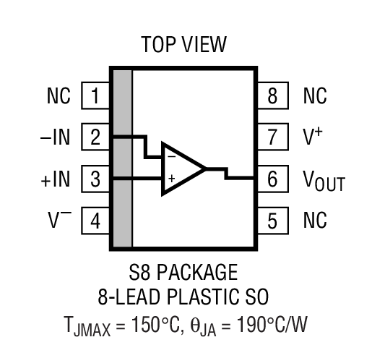
The LT1800 is a low power, high speed rail-to-rail input and output operational amplifi er with excellent DC performance. The LT1800 features reduced supply current, lower input offset voltage, lower input bias current and higher DC gain than other devices with comparable bandwidth. The LT1800 has an input range that includes both supply rails and an output that swings within 20mV of either supply rail to maximize the signal dynamic range in low supply applications.

Working and Characteristics:
The input signal of a sinosoidal wave is passed into the circuit, when the signal goes positive; the positive biased transistor conducts while when negative, the negative biased transistor conducts. During each cycle both complementary transistors turn “ON” and “OFF” alternately and it conducts only half the time through an angle of 180 degrees either on a positive or a negative cycle.
The limitation however is that when the individual half cycles are hypothetically joined together, they do not form a perfect original sinosoidal waveform. There are some distortions inbetween the two. This is caused due to the fact that transistors need a starting voltage to conduct and the part of the waveform that falls between this range of non offset voltage level and the threshold level will not be produced accurately. These are called crossover distortions and a voltage bias needs to be applied to both the transistors to overcome the same. Cross over distortions occur in class B push pull amplifiers in the output signal as a result of non linear input characteristics of transistors. The transistor will turn on at a slightly higher biased voltage across the transistor junction.

Applications: CMOS high power amplifiers, solid state relays and high side switching techniques.

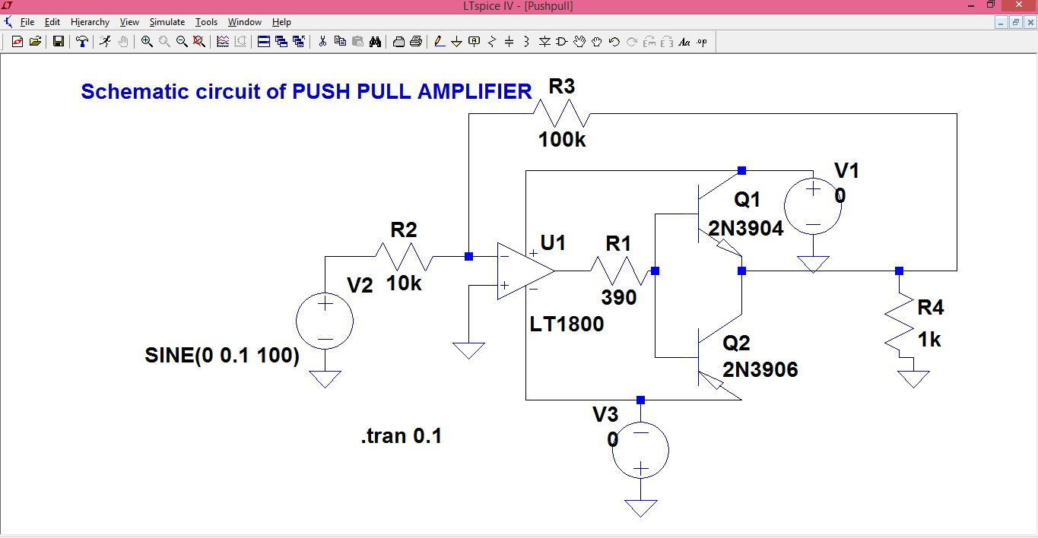
Schematic and simulation working:
Fig.1
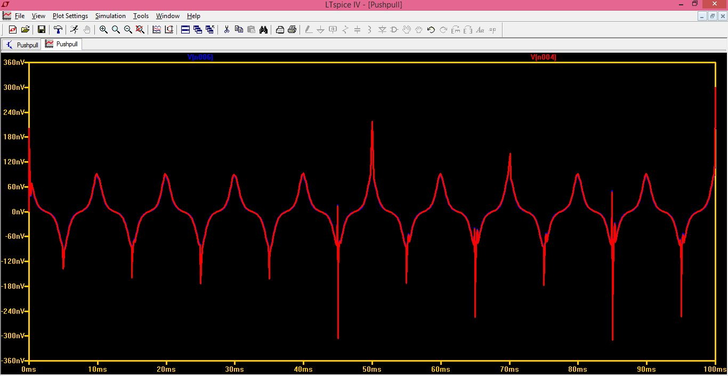

Fig.2
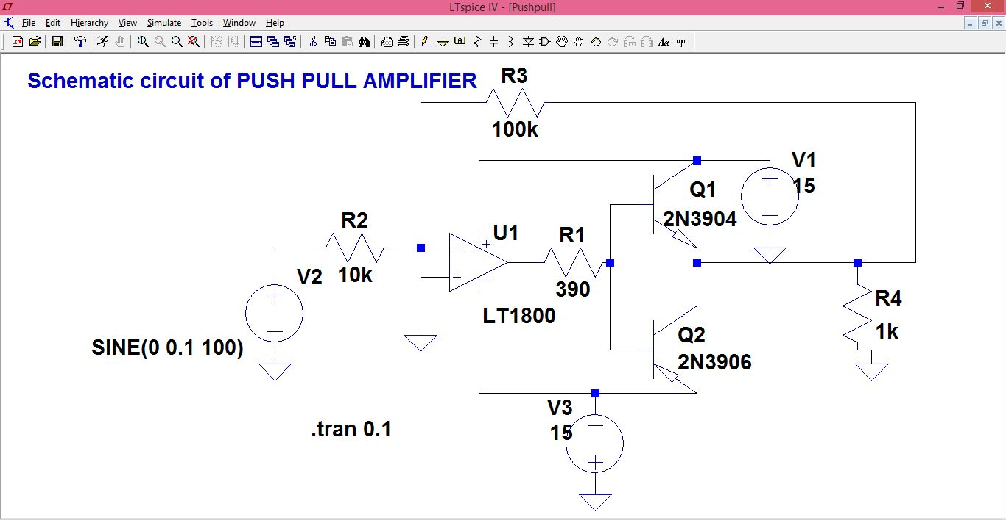
Fig.3

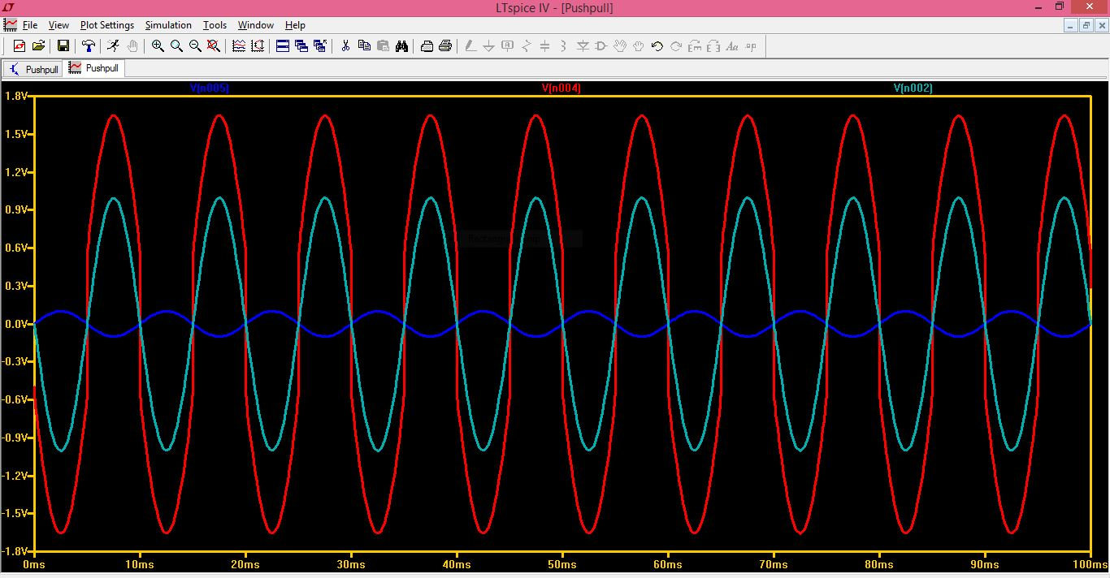
Fig.4

